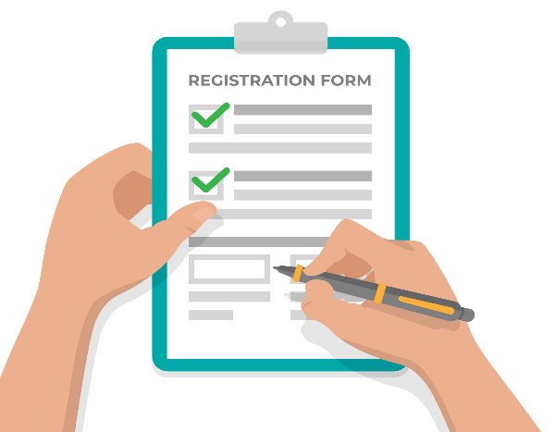

- 
CONTACT US:038568478
LOCATION: NEAR CITY ROAD ISLAMABAD
COMSATS UNIVERSITY
ISLAMABAD

FACILITES:

Experienced teachers
- GOOD Labs and Library
- GOOG Infrastructure

Apply From:
1 FEB 2026
ENTERY TEST DATE:12 FEB 2026
- Postgraduate program
- M Phil
- PHD
This Photo by Unknown Author is licensed under CC BY-SA-NC

